EXPERIMENT -6
RAD- (Rapid Application Developement)
NAME: ZARAA JUHI SAAI K ROLL NO: 240701044

Project Title: TechStore – E-commerce Web Application

Introduction
The TechStore E-commerce Application is a web-based platform that allows users to browse, select, and purchase electronic products such as laptops, audio devices, smartphones, and accessories.
This project follows the Rapid Application Development (RAD) model, focusing on quick development, continuous feedback, and iterative design.

Objective
- To design a user-friendly e-commerce interface
- To implement fast and interactive product browsing
- To simplify online purchasing with cart and checkout features
- To demonstrate RAD methodology in UI/UX development

RAD Model Overview
RAD emphasizes:

- Quick prototyping
- User involvement
- Iterative improvements
- Faster delivery

RAD Phases Applied

Requirement Planning
  - Identified need for an online tech store
  - Defined features: product listing, cart, checkout
  - Target users: online shoppers

User Design
UI was created using Figma with the following screens:

Home Page

  - Welcome banner ("Welcome to TechStore")
  - Navigation bar (Home, Categories, Cart)
  - “Shop Now” button

Category Section

  - Laptops
  - Audio
  - Smartphones
  - Cameras
  - Wearables
  - Accessories

Featured Products Page

  - Product cards with:
    - Image
    - Rating
    - Description
    - Price
    - “Add to Cart” button

Rapid Construction
  - Designed interactive components:
    - Add to cart functionality
    - Quantity adjustment (+ / -)

    - Dynamic price updates
  - Created structured layouts for:
    - Cart summary
    - Checkout form

Cutover (Final Stage)
  - Final UI screens completed
  - Ready for deployment and testing
  - User-friendly navigation ensured

System Modules

User Module
  - Basic navigation (no login shown but extendable)

Product Module
  - Displays all available products
  - Shows details like price, rating, description

Cart Module
  - Add/remove items
  - Increase/decrease quantity
  - Displays subtotal, tax, shipping

Checkout Module
  - Collects user details:
    - Name
    - Email
    - Phone
    - Address
  - Shows final order summary
  - “Place Order” option

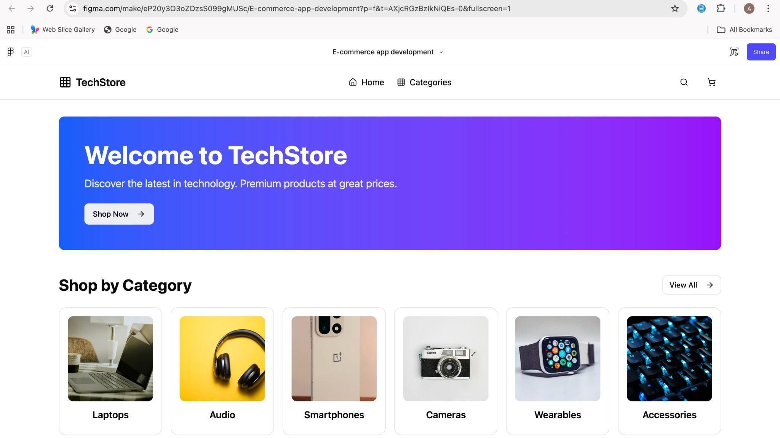
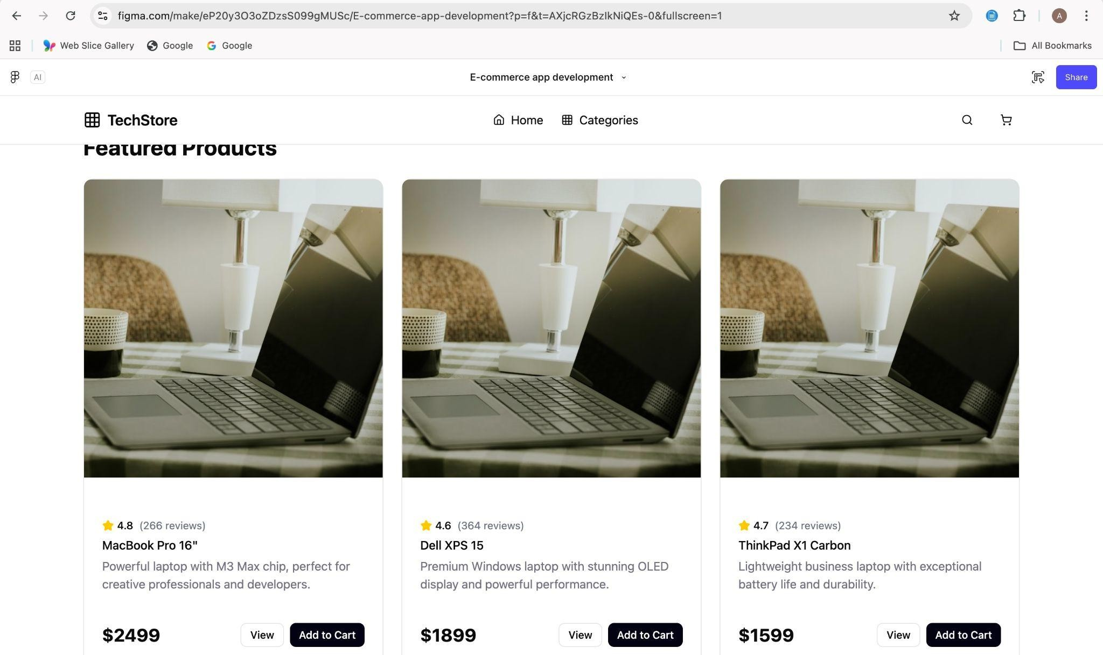

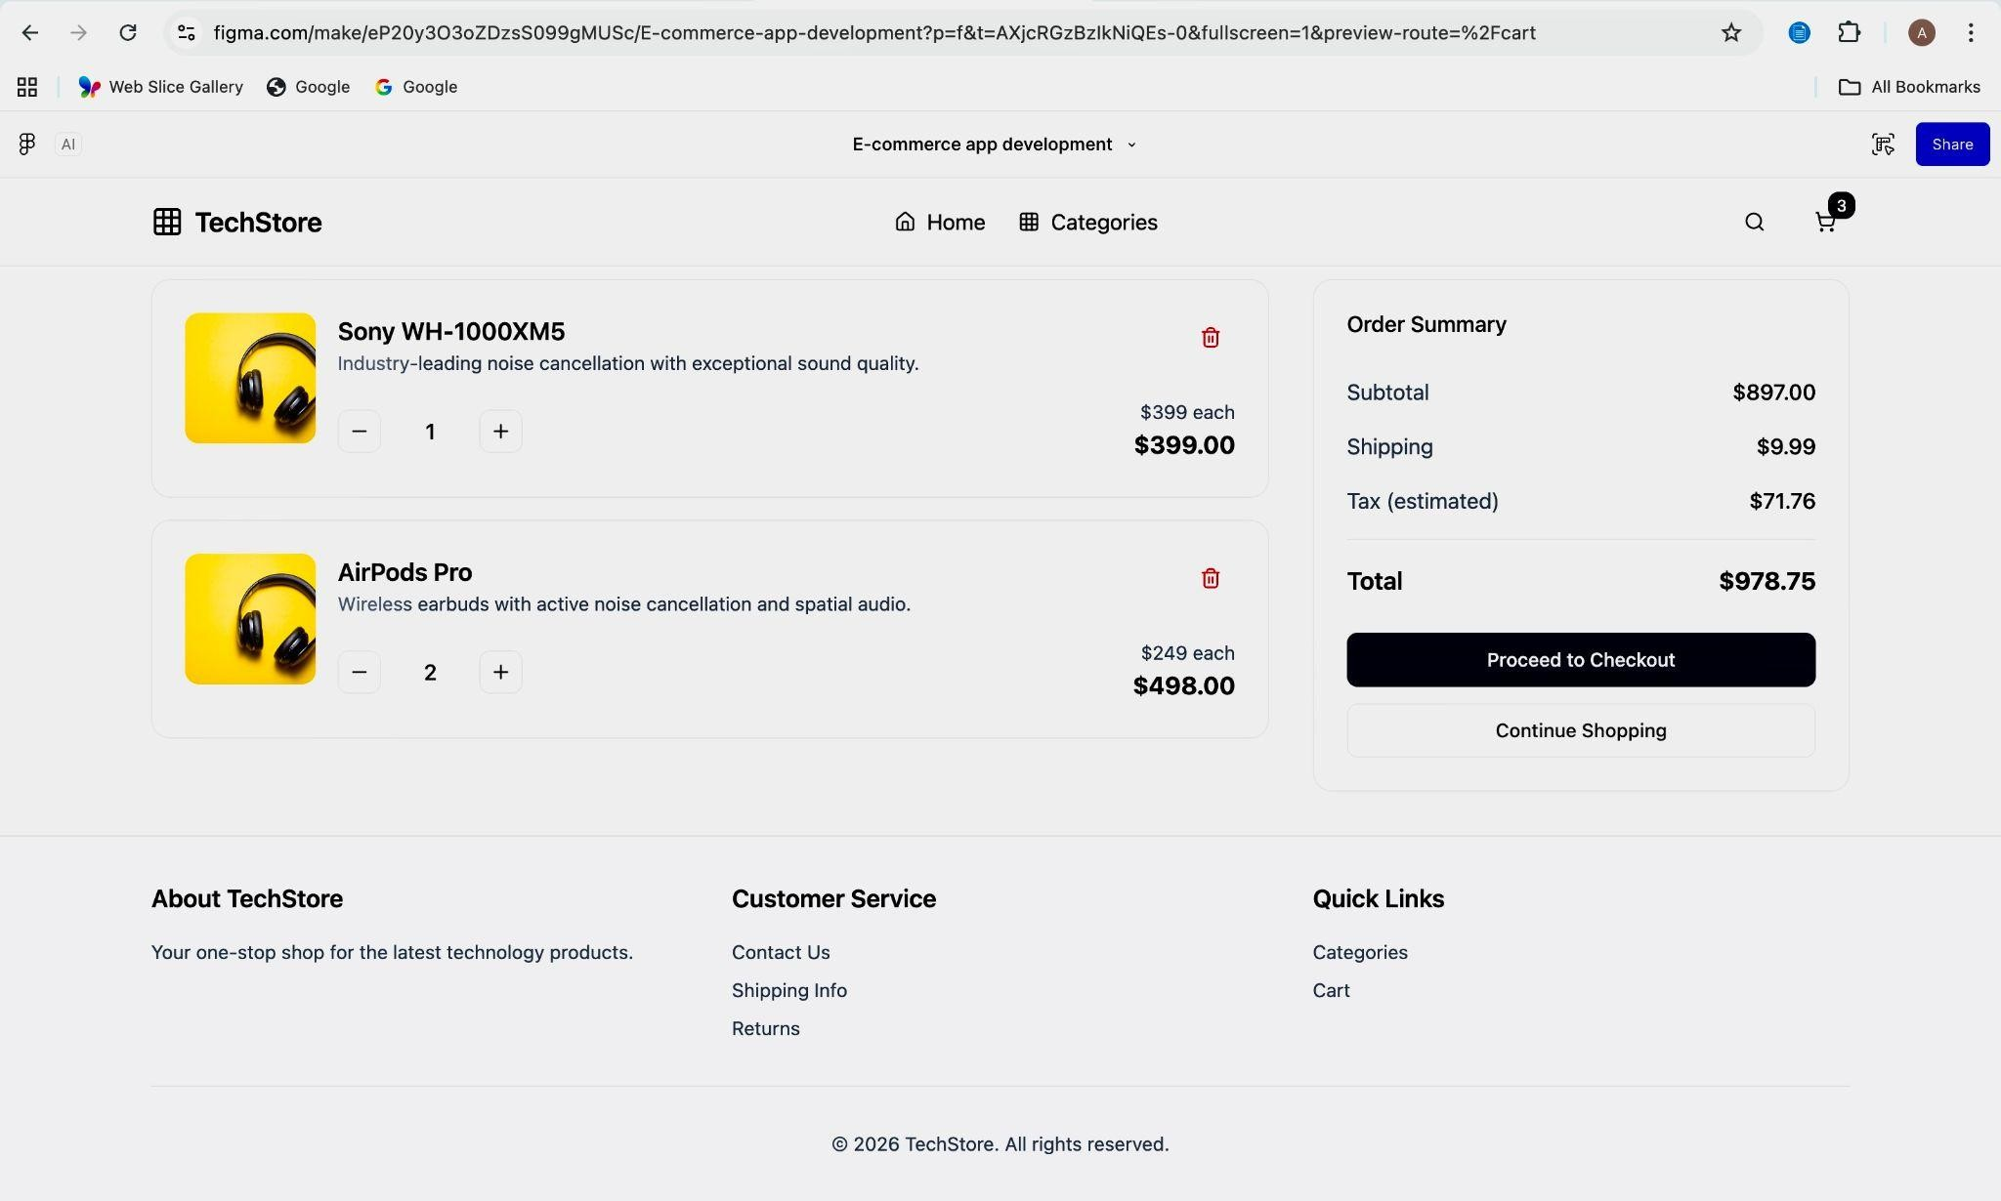
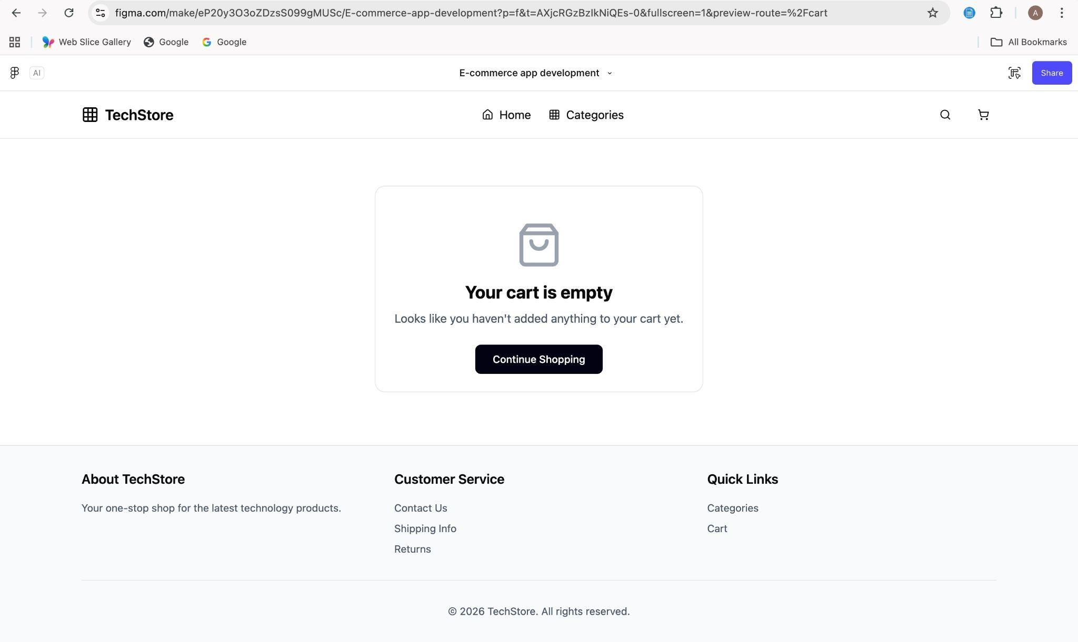

Workflow of the System
- User visits homepage
- Browses categories
- Selects a product
- Adds product to cart
- Reviews cart details
- Proceeds to checkout
- Enters personal & shipping details
- Places order

UI Design Highlights (From Your Screens)
  - Clean and modern layout
  - Gradient banner for visual appeal
  - Card-based product design
  - Simple navigation bar
  - Responsive grid system
  - Clear call-to-action buttons

Tools & Technologies
  - Design Tool: Figma
  - Frontend: HTML, CSS, JavaScript (conceptual)
  - Backend (optional): Node.js / Firebase
  - Database: MongoDB / Firestore

Advantages of the System
  - Easy product browsing
  - Smooth user experience
  - Fast checkout process
  - Scalable for future features

Future Enhancements
  - User login & authentication
  - Payment gateway integration
  - Order tracking system
  - Wishlist feature
  - AI-based recommendations

Conclusion
The TechStore E-commerce application successfully demonstrates the RAD model, allowing rapid UI development with continuous improvements. The system is efficient, scalable, and user-friendly, making it suitable for real-world implementation.

